IN THE EIGHTH JUDICIAL CIRCUIT OF FLORIDA STANDING CASE MANAGEMENT ORDER [AOSC20-23]

THIS ACTION is before the court for case management pursuant to AOSC20-23 (Amendment 10). Therefore, it is ADJUDGED that:
- This case is provisionally designated as a general civil case.

- TRIAL DATE: The projected date for a non-jury trial shall be the first regular trial

term taking place one year after the date of filing. The projected date for a jury trial shall be the first regular trial term taking place eighteen months after the date of filing. A firm trial date will be established by the presiding judge when the case is at issue. Trial term dates for each civil division are published on the Eighth Judicial Circuit Court website at https://circuit8.org/court-
calendars/master-calendars/. In county court cases, any case redesignated by the trial court as

a streamlined case, in cases where the parties request it, or in any other case the trial court deems it appropriate, the trial date may be adjusted to take place sooner. Judges shall apply a firm continuance policy allowing continuances only for good cause shown.
- SERVICE: Unless otherwise extended by court order for good cause shown, service of

complaints should be completed within 120 days of filing. Requests for the addition of new parties shall be filed within 180 days of filing.
- DISCOVERY: Fact and expert discovery shall be completed 60 days prior to the trial

date set forth above.

- PRETRIAL MOTIONS: Objections to pleadings and pretrial motions shall be resolved a

minimum of 30 days prior to the trial date set forth above. Prior to filing ANY motion, counsel

filing the motion shall confer with opposing counsel by telephone or in person in a good faith attempt to resolve the motion. The motion shall contain a good faith statement reflecting the date and time of the conference with opposing counsel. A statement that counsel attempted to confer with opposing counsel is insufficient unless the good faith statement details the date and time of at least three attempts to confer that occurred within the one-month period immediately prior to the filing of the motion.
- MEDIATION: The parties shall conclude mediation at least 90 days prior to the trial

date set forth above.

- Deadlines established herein shall be strictly enforced. “Lawyers must strictly comply with Florida Rule of General Practice and Judicial Administration 2.545(a), which requires lawyers to conclude litigation as soon as it is reasonably and justly possible to do so, and the pandemic alone is not a basis for a lawyer’s failure to prepare a case for trial or otherwise actively manage a case.” This order may be modified at such time that the case is determined to be at issue. Fla. R. Civ. P. 1.440.
ORDERED in Alachua County, Florida, on April 23, 2021.

Mark W. Moseley, Chief Judge
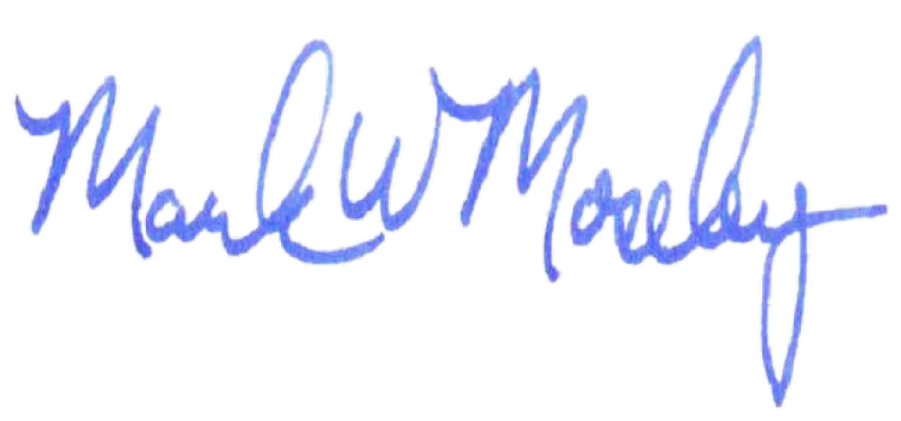
on behalf of all presiding Eighth Circuit civil judges

I HEREBY CERTIFY that I have read and will comply with the foregoing standing order and shall cause it to be filed and served, contemporaneously with the complaint, on all named defendants.

Plaintiff or Plaintiff’s Counsel Date

